

**Worcester Goes Purple &**

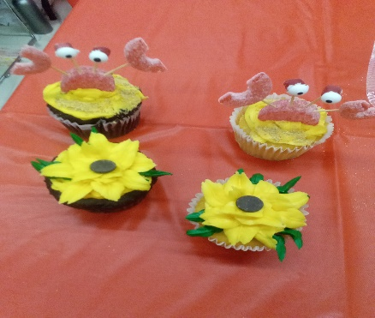 **Worcester County Arts Council**

**Cupcake Decorating**

**Sunday, January 12**

at 11:00pm

$5.00 non-members

$2.50 members

Snacks & 4 Cupcakes, Icing & all decorations included

limited to 25 tickets sold

For those interested in a cupcake or cake decorating as a hobby,

We will have 2 starter kits available to take home for

Cupcake $5.00 or Cake $10.00

($15.00 to 30.00 value)

Tickets sold at the Atlantic Club, for more information call 410-213-1007