

**THAI DYE DAY**

**Make a swirl tie die tee shirt**

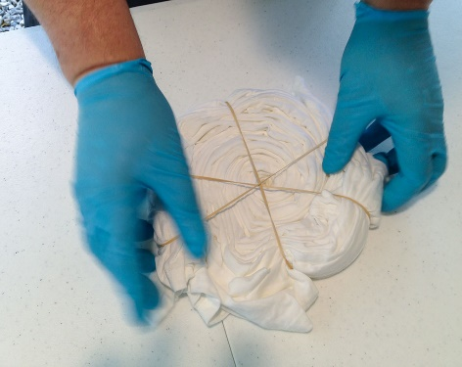

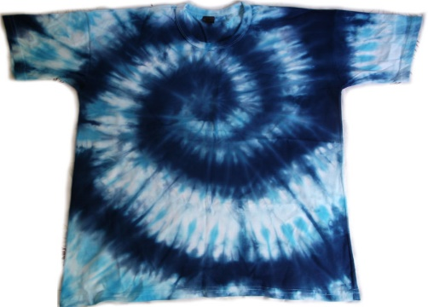

[This Photo](https://www.mundotiedye.com.br/destaque/como-fazer-tie-dye-com-corantes-reativos/) by Unknown Author is licensed under [CC BY-NC](https://creativecommons.org/licenses/by-nc/3.0/)

**& eat some Thai food appetizers**

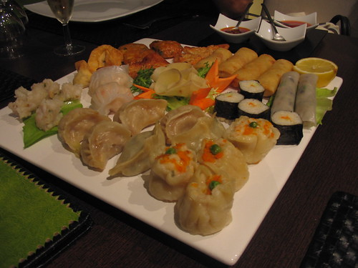

**Sunday, August 4th at 11:00am to 1:00pm**

**$10.00 for non-members & $5.00 members**

Buy your ticket at the Atlantic club, 25 tickets available

For more information call 410-251-8785