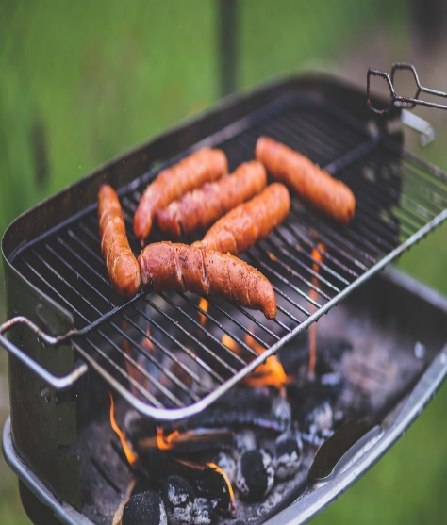

BBQ

&

CORNHOLE TOURNAMENT

SUNDAY, JULY, 14TH 2024

12:00 noon recovery meeting.

BBQ served 1:00pm to 2:00pm

Cornhole tournament begins at 2:00pm

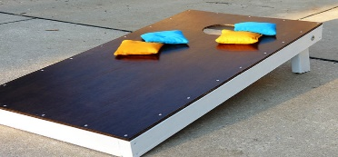

[This Photo](https://www.flickr.com/photos/13045423@N03/6101268121) by Unknown Author is licensed under [CC BY-NC-ND](https://creativecommons.org/licenses/by-nc-nd/3.0/)

Members free & Non-members $3.00

For more info call 410-213-1007